**P5. Structures**

**Benjamín Valdez Rodríguez**

**A00822027**

**Código**

//

// main.c

// P5 Structures

//

// Created by Benjamin Valdez on 2/21/20.

//

#include <stdio.h>

#include <string.h>

**struct** Agent {

**char** name[256];

**char** lastName[256];

**int** age;

**char** gender;

**char** mission[14];

};

**int** main(**int** argc, **const** **char** * argv[]) {

**struct** Agent userAgent;

**char** stringInputs[256];

**int** numberInputs = 0;

**char** charInputs = ' ';

printf("Greetings Agent, I require some information about you!\n");

printf("First of all, what's your first name? ");

fgets(stringInputs, **sizeof**(stringInputs), stdin);

strcpy(userAgent.name, stringInputs);

printf("What's your last name? ");

fgets(stringInputs, **sizeof**(stringInputs), stdin);

strcpy(userAgent.lastName, stringInputs);

printf("What's your current age? ");

scanf("%d", &numberInputs);

userAgent.age = numberInputs;

printf("What's your gender? (M/F) ");

scanf("%s", &charInputs);

userAgent.gender = charInputs;

//To avoid reading the enter as a string

fflush(stdin);

fgets(stringInputs, **sizeof**(stringInputs), stdin);

printf("What's your current mission? ");

fgets(stringInputs, **sizeof**(stringInputs), stdin);

strcpy(userAgent.mission, stringInputs);

**return** 0;

}

**Caso de Prueba 1**

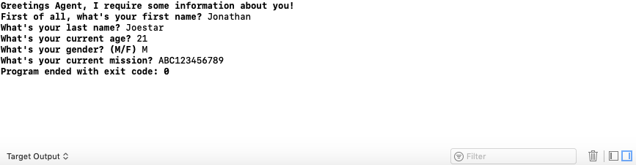

**Caso de Prueba 2**

